IMM Core Transformations

Introduction
This technical note establishes a controlled vocabulary and then uses it to describe how to use the IMM Core Metamodel to transform Models stored in other Peripheral Metamodels, such as XML Schema and Relational Models.
The intent is to establish an understanding among all of the submission team members, achieve consensus, and provide verbiage that can be incorporated into the IMM Submission.

Controlled Vocabulary
A controlled vocabulary supports precise communication for requirements, assertions, and explanations. Following is an abbreviated model of the vocabulary used to describe the transformations (and the terms that I think should be used carefully in the submission). Using these terms should reduce confusion and ambiguity.
(The concepts in the vocabulary that are fully defined on a particular diagram are colored orange, whereas the concepts defined on a different diagram are a faint orange. Within MagicDraw these concepts are hyperlinked such that double clicking one navigates to its defining diagram.)
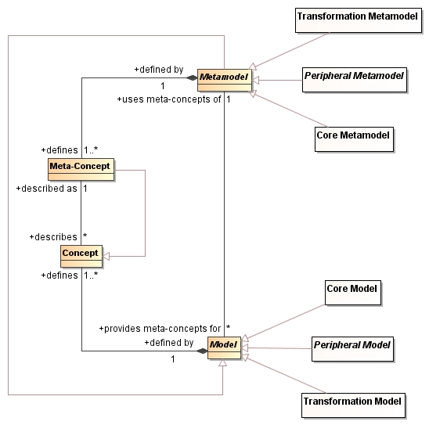
A Model uses the Meta-Concepts of a Metamodel (e.g., Entity or Attribute) to describe Concepts that exist in some domain (e.g., a Bill and its Line Items in the Finance domain).
There are three main kinds of Metamodels: Peripheral, Transformation, and Core.
A Peripheral Metamodel is a metamodel that one can transform into and out of through the Core Metamodel. Examples of a Peripheral Metamodel are the XML Schema and Relational Metamodels. (A complete list is shown in the next diagram.)
A Transformation Metamodel is a vocabulary for describing how meta-concepts in one Metamodel correspond to Meta-Concepts in another Metamodel. For example, a complex type Meta-Concept in the XML Schema Metamodel might correspond to a table Meta Concept in the Relational Schema Metamodel.
The Core Metamodel is already described in detail in the IMM submission, but one thing that is not mentioned in the submission yet is that it provides a set of Meta-Concepts, where every Meta-Concept exists in at least two other Peripheral Metamodels.

Given a set M of Metamodels
M = {XSD, Relational, ER, LDAP, UML, ODM}
and a set of proposed core concepts Core, Core is a valid set of core concepts iff
∀ C in Core, ∃ x, y ((x ∈ M) ∧ (y ∈ M) ∧ (x ≠ y) ∧ (C ∈ (x ∩ y)) )
These core concepts are augmented with some infrastructural concepts, such as Contexts, which are described in more detail, below.
A Metamodel is also a kind of a Model, such that its Concepts are defined as Meta-Concepts of another Metamodel. [Note: saying this may not add much value, and I think I should change the model to define MOF as a Meta-Metamodel to fully unroll the closure and make this more understandable.]
The following diagram expresses the controlled vocabulary for the kinds of Metamodels and Models that exist in IMM. By redefining the allowed types in the association between Model and Metamodel, the diagram makes which kinds of Models use the concepts of which kinds of Metamodels explicit.
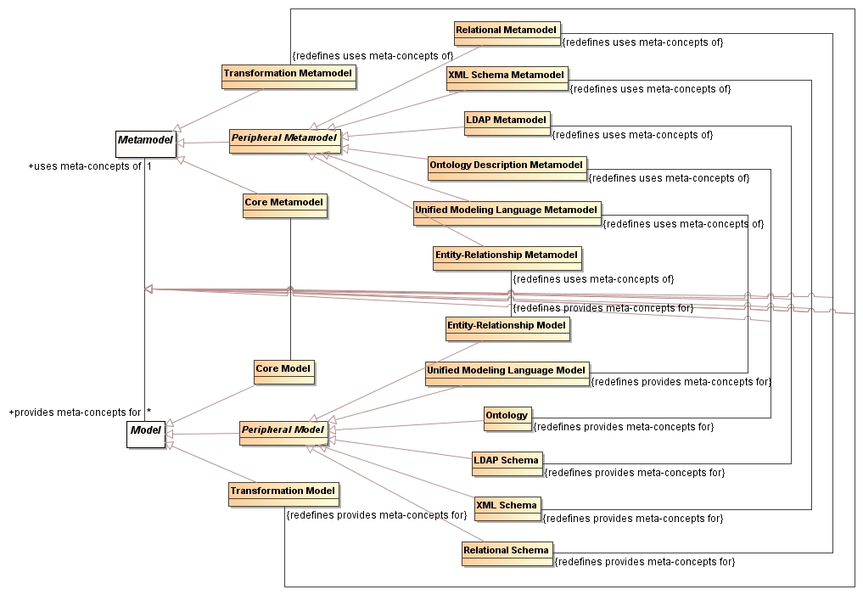

Transformations
There are two different kinds of transformation activities described here. There is a Transform Peripheral Metamodel to Core activity, and a Transform Core to Peripheral Metamodel activity. They both share a generic Transformation-Model-driven activity called Transform Model Elements, but a transformation from the Core into a Peripheral Metamodel requires an extra action. [Note: these activities could be combined, but I think it is clearer to separate them.]
(Note: these diagrams do not use redundant initial nodes, activity final nodes, or control flows. The execution semantics of UML activities is such that any activity can begin when the required data is offered to all its pins.)
The Transform Peripheral Metamodel to Core activity consumes a Peripheral Model and produces a Core Model. This activity simply collects the information needed to invoke the Transform Model Elements activity and outputs a Core model. The Transform Model Elements activity uses a Transformation Model to determine how to transform Meta-Concepts in the input Metamodel into Meta-Concepts in the output Metamodel. [Note: The Mapping Model details will remain unclear until the submission team completes the EU-Rent example in all Metamodels.]
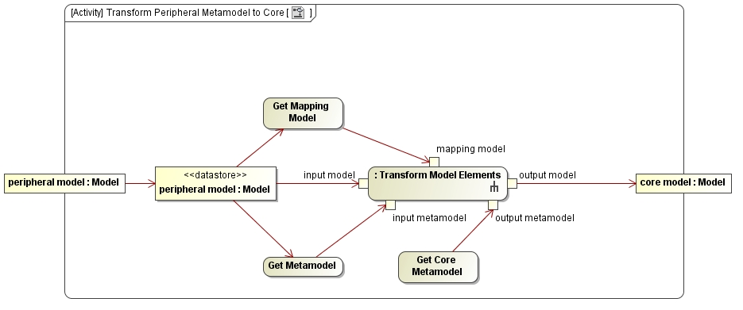
The Transform Core to Peripheral Metamodel activity consumes a Core Model and uses a Peripheral Metamodel to determine what kind of Peripheral Model to create.
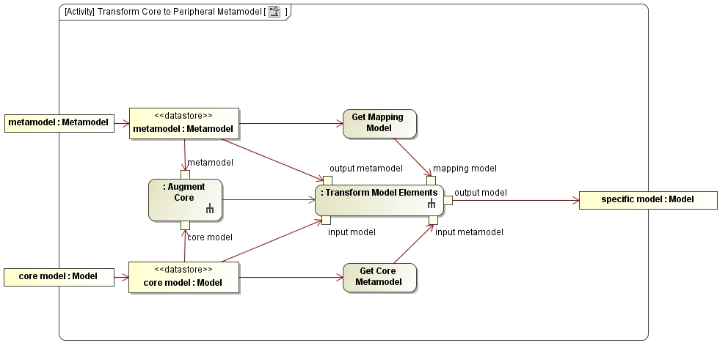
Before it actually transforms anything, this activity creates a new Context in the Core Model, then it augments the Core Model with any Meta-Concepts that are required by the transform. Those Meta-Concepts exist only within that new Context, and are only applicable to the output Metamodel, so they remain hidden from anything that does not explicitly use that Context. This augmentation is necessary because of the feature differences between Peripheral Metamodels, as shown in the table that follows. The augmentation also maps datatypes and primitives according to the mapping rules established in [what should we call "IMM Datatype Library.mdzip"?].
When the Core Metamodel is used as a permanent repository, the Context is important because it allows both the unaltered Core Model to coexist with the augmented Core Model. All of the adjustments for each Model type (i.e., Metamodel) can coexist in the repository simultaneously, including different names for Concepts, defaulted Concepts, and even refactorings, such as the coalescing of inherited Identifiable Types for implementation in one Relational Table.
When the Core Metamodel is used only for a transformation, the Context is helpful because it separates the original Core Model from the augmentations.
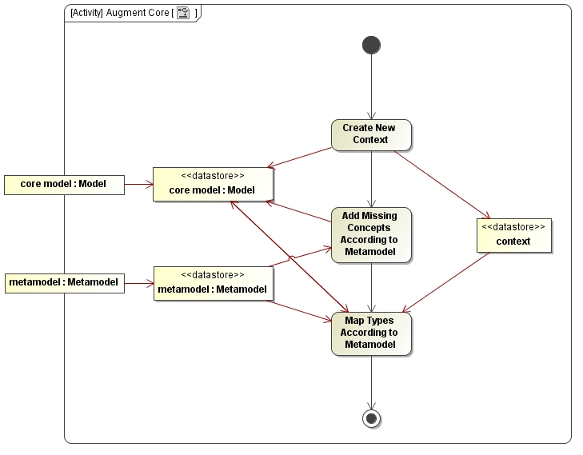
This table shows some of the features that differ among the Peripheral Metamodels, using single letters to signify Unsupported (U), Optional (O), Expected (E), or Mandatory (M). Unsupported means the Metamodel has no Meta-Concept to represent the feature. Optional means the Metamodel has a Meta-Concept to represent the feature. Expected means the Metamodel has a Meta-Concept to represent the feature, and the feature is expected by its users. Mandatory means the Metamodel has a Meta-Concept to represent the feature, and the feature is required for the technology to function correctly.
Feature | XSD | Relational | ER | LDAP | UML | ODM
Spaces in Names | U | U | E | M | O | O
Case Significance in Names | M | O | M | O | M | M
Unique Identifiers | O | E | E | M | U | U
References | O | E | E | M | U | U
Containment | E | U | E | O | O | U
Generalization | O | U | E | M | E | E
Association | U | U | E | U | E | E
For example, the Relational Metamodel requires primary keys to function correctly, whereas they are optional in an XML Schema Metamodel. The augmentation would determine that primary keys are missing after a transformation of an XML Schema Model into the Core Metamodel and add default primary keys to all the Identifiable Type instances to prepare the Core Model such that the actual transformation into a Relational Model will succeed.
[Note: the submission team must discuss whether the augmentation must take place for Expected features or only for Mandatory features. The team must also determine how the augmentation will take place and whether it is indeed possible and useful in all cases.]

- Common augmentations
- More about this table semantics

